

**Final Project Report**

**Access Information:**   
URL: <http://cscie60.dce.harvard.edu/~iogbo/fp/index.cfm>

**Goals and Purpose:** XYZ Autos is a family owned company which exports new, used and pre-owned cars to Africa from America. XYZ Autos was founded by me (Ikechukwu) and my siblings in Nigeria in November, 2009. Since then, XYZ Autos has exported up to 200 cars to Africa. XYZ Autos has been successfully providing the customers with timely delivery and transparency.

The main purpose of this application is to replace the old fashioned order placing through emails and phone calls. This application will also serve as a great advertisement for the company. We will include the application to our flyers, business cards and stickers. The customers will find it more convenient to place their order and see sample of cars in the inventory. It will reduce amount of time it takes to correspond with customers while sending description and pictures through emails and phone calls. The description of cars in the inventory will be visible on the application thereby creating a good picture and feeling for the customers. Also, it will boost the company’s believability and credibility

**Implementation:** the application is built to be user friendly. The navigation through the site is self-explanatory and will guide the user directly to what they are looking for. The application consists of several pages but the main pages that were implemented in this project are as follows

*HOME:* the home page has a little description on what XYZ Autos is about. Though there is an **About XYZ** page that has detailed information on XYZ’s modus operandi. The brief description has a read and collapse buttons. These buttons were designed using Jquery library. The link to the home page is <http://cscie60.dce.harvard.edu/~iogbo/fp/index.cfm>

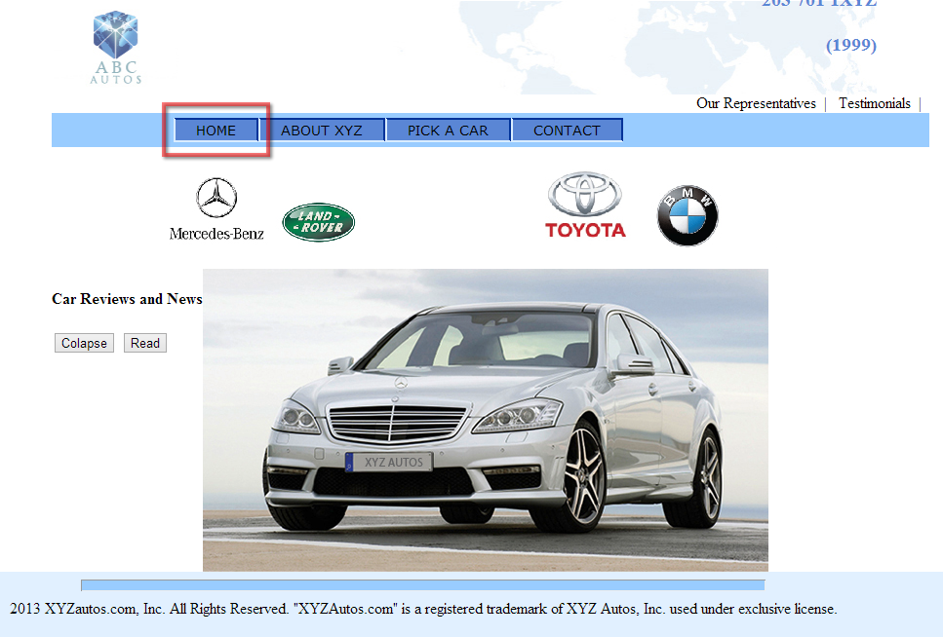

*ABOUT XYZ:* Contains a detailed information on XYZ operations and learning history of the company. The link to About XYZ page is <http://cscie60.dce.harvard.edu/~iogbo/fp/about.cfm>

*PICK A CAR:*  this page contains XYZ inventory. Which is the items that have not been sold yet. A customer is required to click on the **StockID** of any of the cars they are interested in. This will send them to an **Order Form.** The link to the home page is <http://cscie60.dce.harvard.edu/~iogbo/fp/searchinventory.cfm>

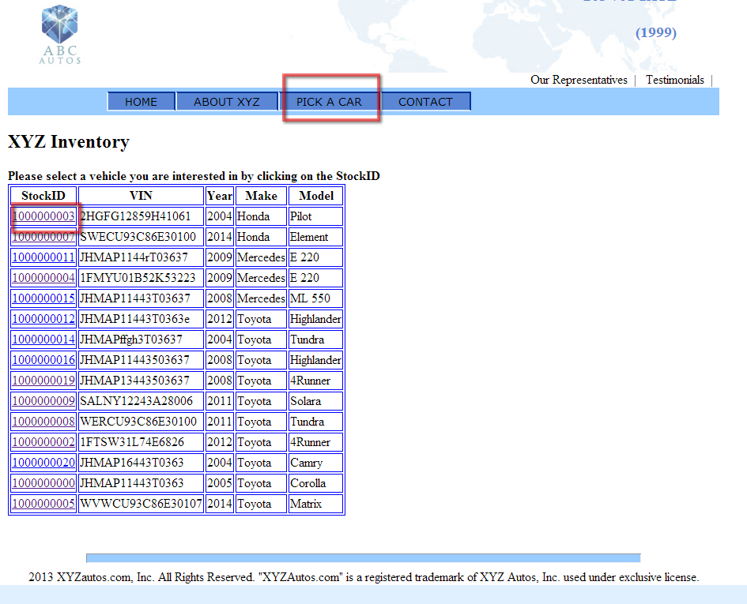

*Order Form:*  this page contains an order form where customer fill out the form to put enter their personal and payment information to XYZ database. This is like the checkout page. Customers place their order here and XYZ receives it and process their shipment.

In this page, **StockID** that was clicked in **Pick a Car page** is passed through URL to the page. You will notice that **StockID** field has already been entered.

The country and the State can be selected by a drop down menu. This was done with the help of Javascript.

Each field has validation not to exceed the number maximum or minimum text required whatever the case may be.

There is a check box on the page that fills out **billing information** if it is the same as **shipping information**

Users select **Sales Rep** with a dropdown menu. This will be hardcoded-in since the sales representatives will on be family members. Also the default sales rep will be Ike if the user doesn’t know their sales rep.

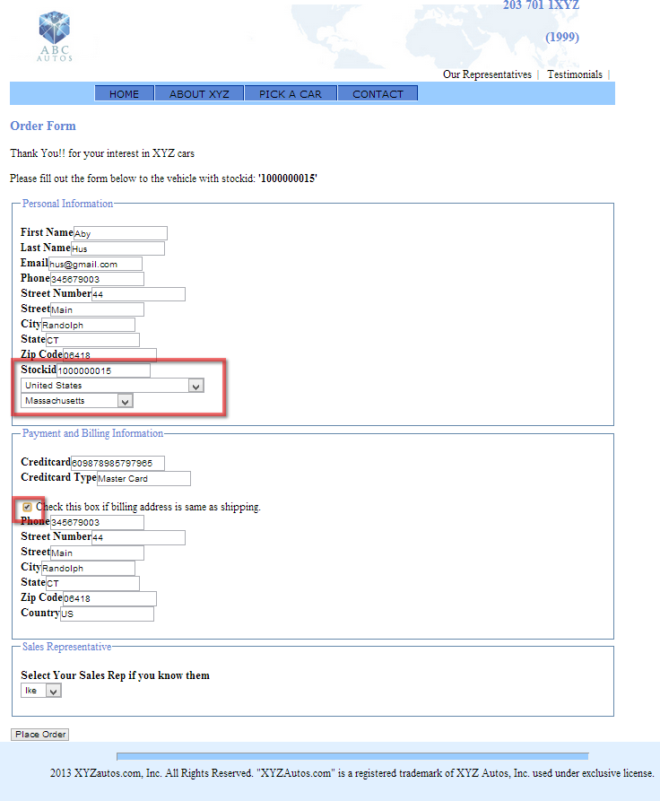

*Contact Us:*  I pointed this page to the inventory page just for the sake of the project.

*Our Representatives:*  this page contains an add inventory form where the admin fills out the form to enter a new inventory.

The page contains three brands of cars sold by XYZ Autos in the dropdown menu. Those brands should have gone to a database but I left it at the HTML in order to use JavaScript to select different **Models** for a particular **Make.** This page contains an order form where customer fills out the form to put enter their personal and payment information for flexibility.

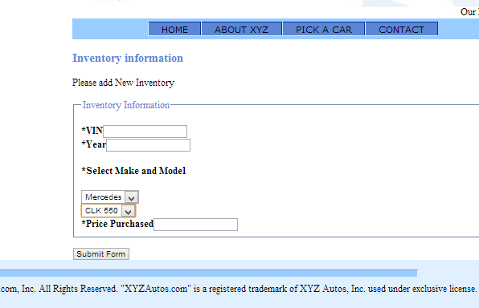

**A listing of Bugs:**

1. I couldn’t get the page **Our Representatives** to be password protected so that users don’t go in and enter inventory.
2. In the order form, when you click refresh the action page, it creates new order. I couldn’t get this to stop happening.

**Special features:**

*Error Handling:*  I implemented error handling for all the forms in the application. If required fields are not filled out, the application throws an error to the page.

*Triggers and Sequences:*  I made use of triggers and sequences in to automate the database as good as possible. Find the triggers in the .sql file.

*User friendliness:*  I implemented user friendliness in the reports as well as the whole app such as,

Checkbox to copy shipping information to billing information fields in the order form.

Passing stockid number through URL and actually filling it out for the user in the order form.

Dropdown Menu in the **add inventory** form that selects different **Models** for a particular **Make.**